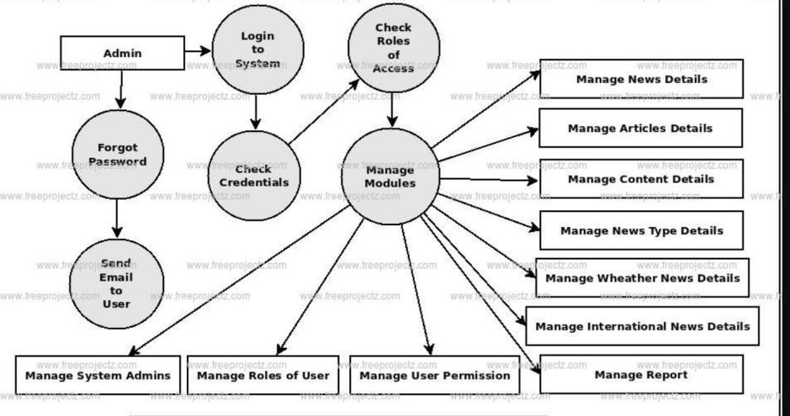

# Project Design Phase-II

**Data Flow Diagram & User Stories**

|  |  |
| --- | --- |
| Date | 16 navember 2022 |
| Team ID | PNT2022TMID49399 |
| Project Name | News tracker Application |
| Maximum Marks | 4 Marks |

## Data Flow Diagrams:

A Data Flow Diagram (DFD) is a traditional visual representation of the information flows within a system. A neat and clear DFD can depict the right amount of the system requirement graphically. It shows how data enters and leaves the system, what changes the information, and where data is stored.

DFD -News tracker Application login & management flow:

## Example: [(Simplified)](https://developer.ibm.com/patterns/visualize-unstructured-text/)

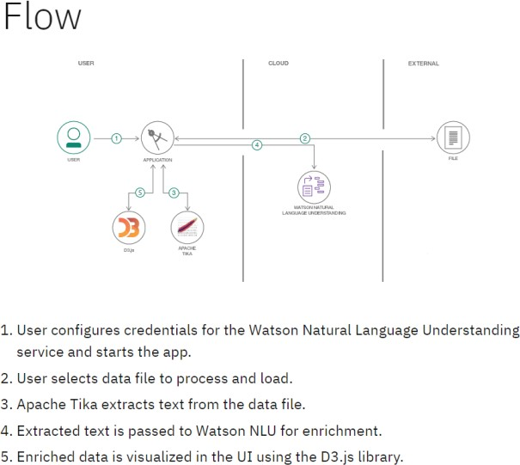

**User Stories**

Use the below template to list all the user stories for the product.

|  |  |  |  |  |  |  |
| --- | --- | --- | --- | --- | --- | --- |
| **User Type** | **Functional**  **Requirement (Epic)** | **User Story Number** | **User Story / Task** | **Acceptance criteria** | **Priority** | **Release** |
| Customer (Mobile user) | Registration | USN-1 | As a user, I can register for the applicationby entering my email, password, and confirming mypassword. | I can access my account / dashboard | High | Sprint-1 |
|  |  | USN-2 | As a user, I will receive confirmation email once I have registered for the application | I can receive confirmation email & click confirm | High | Sprint-1 |
|  |  | USN-3 | As a user, I can register for the application through QR code | I can register & access the dashboard by scanning the QRcode | Low | Sprint-2 |
|  |  | USN-4 | As a user, I can register for the application through google | I can create a new password | Medium | Sprint-1 |
|  | Login | USN-5 | As a user, I can log into the application by entering email & password | If I forgot the password, then I will receive a mail for creating another password or alternate  login credentials. | High | Sprint-1 |
|  | Dashboard |  |  |  |  |  |
| Customer (Web user) |  |  |  |  |  |  |
| Customer Care Executive |  |  |  |  |  |  |
| Administrator |  |  |  |  |  |  |
|  |  |  |  |  |  |  |
|  |  |  |  |  |  |  |
|  |  |  |  |  |  |  |